Original code:

if there's **bidirectional scanning** and the options.shifts\_method is 'fft' (which is true for both granule\_love2.tif and dNMF/.../original.tif)**, then options.shifts\_method** would be **changed to 'cubic' (bicubic interpolation)**

Recap

Unidirectional laser scanning Bidirectional laser scanning

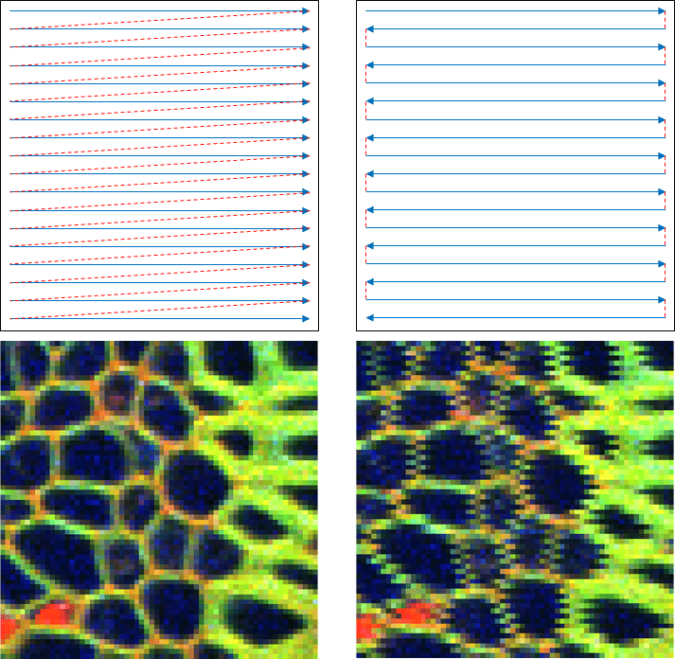

(Top row) Unidirectional (left) and bidirectional (right) trajectory for laser scanning microscopy acquisition. The dashed red line depicts the laser movement between pixel acquisition (idle); and the solid blue line denotes the active acquisition movements. (Bottom row) Example of jaggedness artefacts apparent during unidirectional (left) and bidirectional (right) line acquisition shown in zoom of the region of interest on a plant sample Convallaria majalis. It can be seen that the variable speed of the laser induces geometric distortions in the final acquired images.

Ref: <https://www.researchgate.net/publication/332750078_Image-Based_Artefact_Removal_in_Laser_Scanning_Microscopy>

Should set bidirectional correction to True for granule\_love2

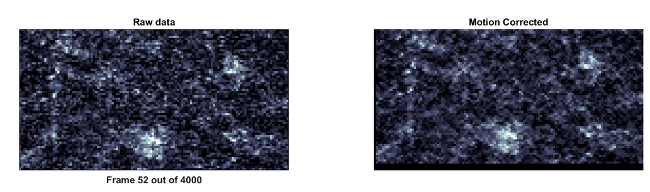

Offset 7.0e-01 pixels due to bidirectional scanning detected.

Might not be needed for dNMF example (As the offset detected is a whole lot smaller: 2 << 7 pixels; even if corrected, not a lot of impact…)

D:\Diane\Col\2021Fall\Statistical_analysis_of_neural_data_GR8201\final_project\code\dNMF\colab_demo_results\size_64_128_2_1000_30\original.tif

Offset -2.0e-01 pixels due to bidirectional scanning detected.

TODO: can change the original code such that can also correct for bidirectional scanning when using fft interpolation

基本上只要每個間隔的row shift加上col\_shift? From cubic: shifts\_up(2:2:end,:,:,2) = shifts\_up(2:2:end,:,:,2) + col\_shift;